Supplementary figure legend.

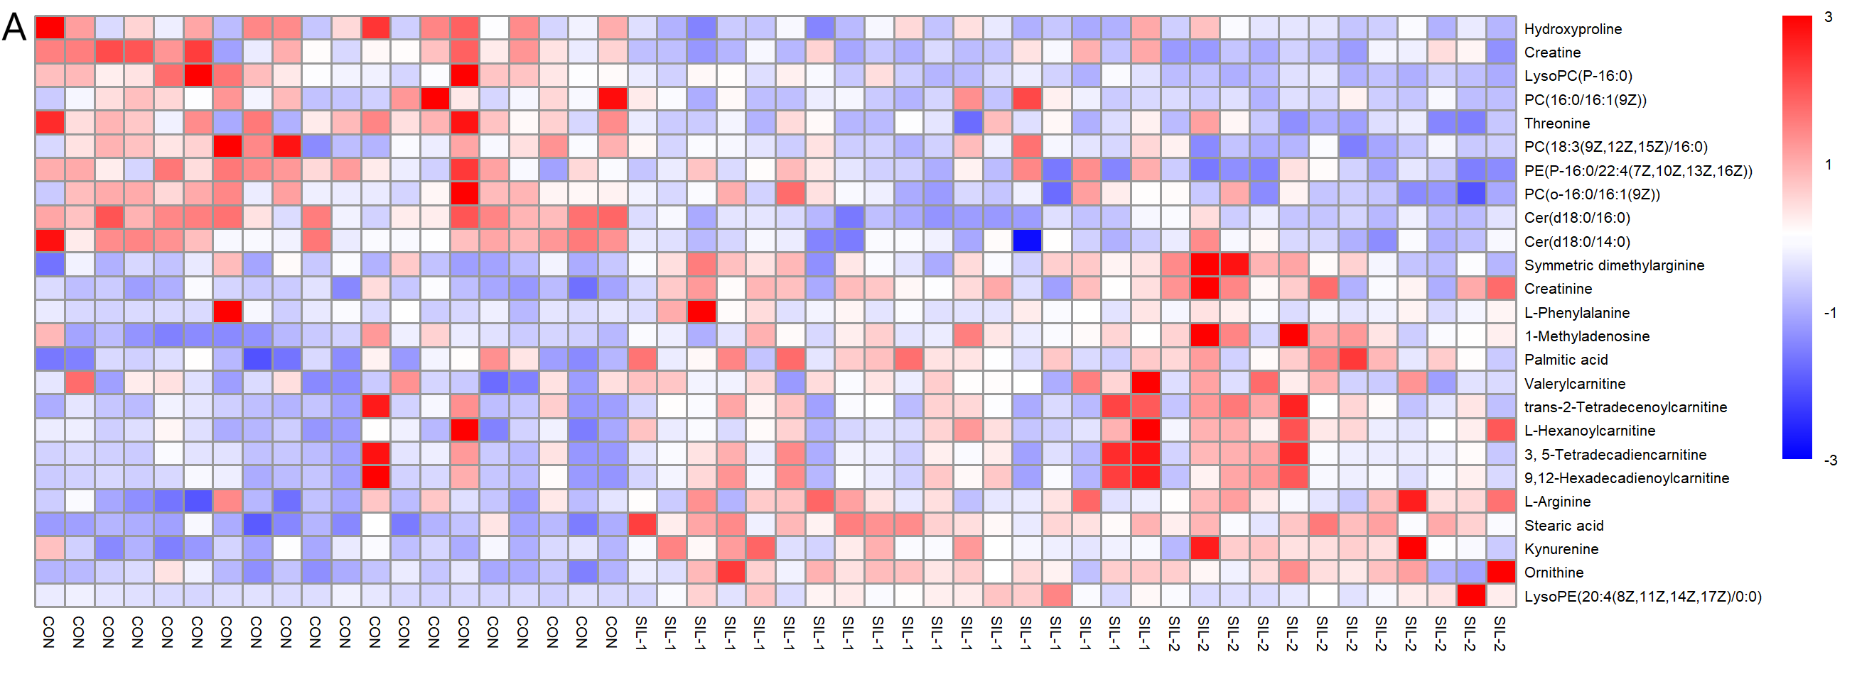
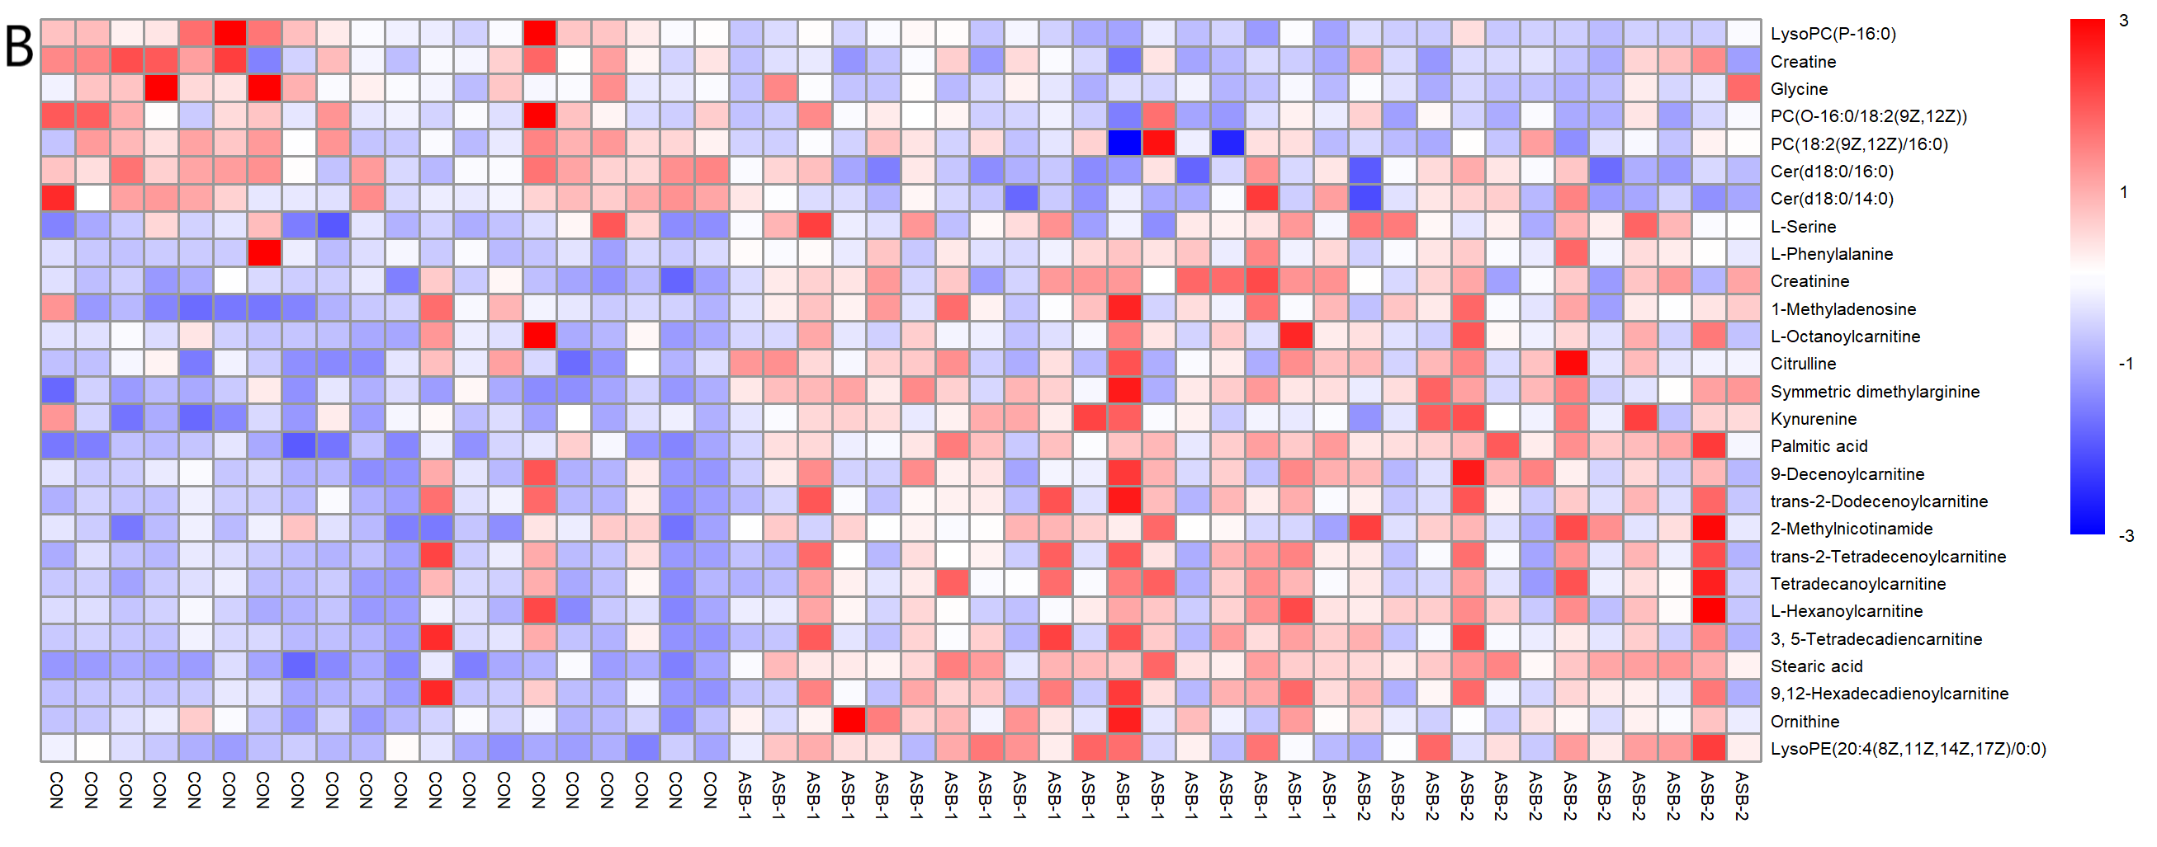
Figure S1 Heat maps of plasma metabolites of silicosis and asbestosis subgroups compared with that of healthy controls (CON). (A) simple silicosis (SIL-1) (n=18) and complicated silicosis (SIL-2) (n=12) vs CON (n=20); (B) asbestosis with DLCO≥60% pred (ASB-1) (n=19) and asbestosis with DLCO < 60% pred. (ASB-1) (n=11) vs CON (n=20)

